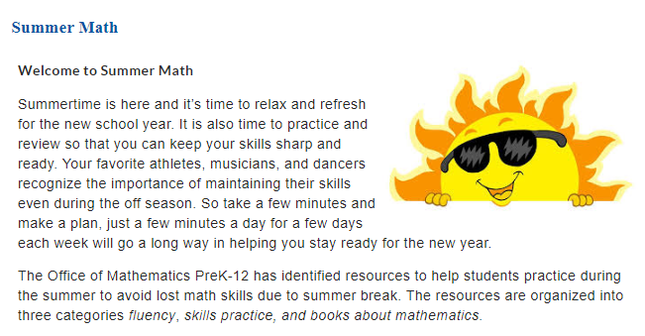
Visit https://tinyurl.com/BCPSelementarysummermath to access the materials. Click the grade level or course your child will be entering in the Fall 2018 to get started.

Visit https://tinyurl.com/BCPSelementarysummermath to access the materials. Click the grade level or course your child will be entering in the Fall 2018 to get started.

